
Focussed Intervention Funding (FIF)
DSPL7 quick reference guide for schools

Please refer to the local authority FIF guidance for full details about making an application

Overview
Focussed Intervention Funding (FIF) will replace LHNF and starts in April 2026
FIF is for a time-limited/focussed intervention to help children/young people who need provision that is more than OAP but who are unlikely to need an EHCP. They must be attending school for at least part of the day. If you are considering applying for an EHCNA, then it wouldn't be appropriate to apply for FIF. There is a different process for Early Years funding (see full FIF guidance).

What is a Focussed Intervention?
A focussed intervention is time-limited provision that addresses an identified gap that is preventing a child or young person from accessing the learning, developing key skills and making progress.
Examples of interventions could include:
- A programme to develop social communication skills and strategies
- A programme to support behaviour
- A programme to support a young person to overcome EBSNA difficulties
- An intensive speech and language programme
- A therapy programme
- A catch-up tuition programme

Criteria
You can apply for FIF to support children/young people whose needs fall into these areas:
- Children in Early Years who have already received EY Targeted 2 funding, but need more support
- Children arriving in Reception with complex needs, but who are unknown to the EY team
- Children/young people who have experienced a life-changing event which prevents them from accessing learning. (The child will likely need an EHCNA in the longer term).
- Children/young people with emerging needs that fall outside of the EHCP process.

If schools have 4 or more pupils with similar needs, from September 2026 you can apply for group funding to put an intervention in place. The same criteria apply for group funding requests.

FIF Clusters/Panel
- All mainstream schools in DSPL7 will be allocated to a cluster group (see lists below)
- Clusters will meet once each half term, either in person or online
- Clusters will discuss the applications for that group and decide which ones meet the criteria
- Clusters will send the agreed applications to the main FIF panel who will make the final decision
- Having an application agreed at cluster is no guarantee that funding will be awarded.
- 2 Lead SENCos will be required to attend the main FIF panel each half term
Cluster Groups

Cluster 1 Harpenden North
Harpenden Academy
Roundwood Primary
Sauncey Wood
Kimpton
Wood End
The Lea
Manland
St Nicholas

Cluster 2 Harpenden South
Redbourn
Grove Infants
Grove Juniors
St Dominic’s
High Beeches
Crabtree Infants and Juniors
St Helens
Beech Hyde

Cluster 3 Secondary
Beaumont
KWS
Loreto
Marlborough
Nicholas Brakespear
Roundwood Park
Samuel Ryder Secondary
Sandringham
Sir John Lawes
Stags
St Georges
Townsend
Verulam

Cluster 4 St Albans Primary A
Aboyne Lodge
Bernards Heath Infants
Bernards Heath Juniors
Garden Fields
Margaret Wix
Sandridge
Skyswood
St John Fisher
St Michael’s
Wheatfields Infants
Wheatfields Juniors

Cluster 5 St Albans Primary B
Abbey
Alban City
Camp
Cunningham Hill Schools
Fleetville Infants
Fleetville Juniors
Maple
Oakwood
SS Alban & Stephen
St Peters
Windermere
Samuel Ryder Primary

Cluster 6 St Albans Primary C
Bowmansgreen
Colney Heath
How Wood
Killigrew
London Colney
Mandeville
Mount Pleasant Lane
Park Street
Prae Wood
St Adrians
St Bernadettes

Making a FIF application
- Complete the new application form
- Make sure you have 2 current reviewed APDR cycles
- Complete a VSEND pupil profile (or something similar) that shows the pupil’s needs
- Add any other attachments you think are relevant
- Send the documents to FIF@dspl7.org.uk by the application deadline

What happens next?
- Each cluster will have an applications folder
- When applications are received they will be added to the cluster folder ready for the meeting
- Before the cluster meeting, SENCos will be sent a link to the folder so they can read the applications
- Access to the folder will end after the cluster meeting has been held

Cluster meeting
- Each cluster will have a Lead SENCo. This could be the same person for every meeting, or members of the cluster could take it in turns.
- SENCos who have submitted an application will present it at the cluster and answer any questions or clarify details
- The cluster will decide whether the application meets the criteria and is appropriate
- If yes, the application will be added to the list for consideration at the main DSPL7 FIF panel
- If no, strategies and next steps can be offered from the other cluster SENCos and professionals
- The outcome is recorded on the cluster form and saved into the cluster folder

Role of the Lead SENCo
Lead SENCos will be paid £100 per cluster meeting to:
- Read the applications in advance
- Chair the cluster meeting
- Record the outcomes on the cluster spreadsheet
- Return the spreadsheet to the DSPL7 manager

Main FIF Panel
- All applications agreed at cluster meetings will be reviewed by the main panel
- The main panel will consist of the DSPL7 manager and SEND leads, 2 Lead SENCos, a Headteacher Rep and another professional
- Lead SENCos will be paid £100 if they attend the main panel.
- The panel will review the decisions made by the cluster groups to check that they meet the criteria and the intervention is suitable for funding
- If yes, the panel will decide upon the length of time for funding
- The DSPL7 manager will inform the schools of the decisions

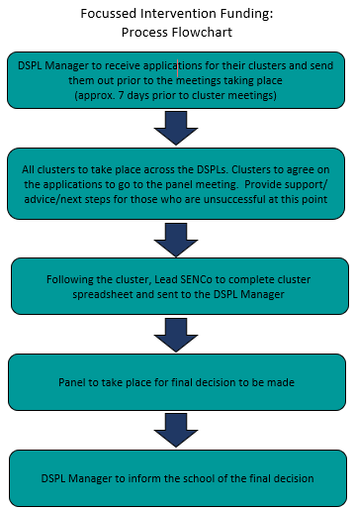o

Key Dates

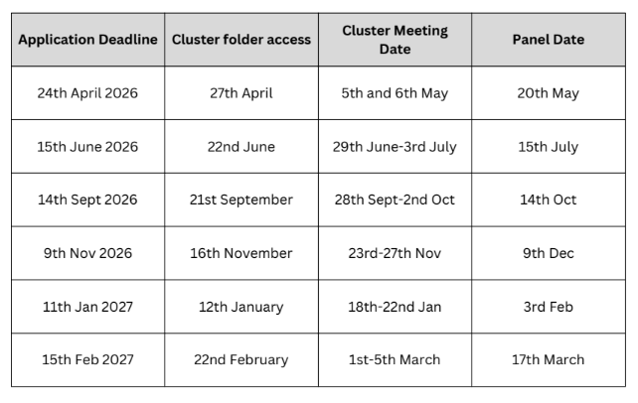

Information about the first cluster meetings

The first cluster meetings will be held online on 5th/6th May and chaired by the DSPL7 team.

5th May

Cluster 1 | 9 – 10.30am | FIF cluster 1 | Meeting-Join | Microsoft Teams
Cluster 2 | 10.30am – 12pm | FIF cluster 2 | Meeting-Join | Microsoft Teams
Cluster 4 | 1 – 2.30pm | FIF cluster 4 | Meeting-Join | Microsoft Teams
Cluster 5 | 1-2.30pm | FIF cluster 5 | Meeting-Join | Microsoft Teams

6th May

Cluster 3 | 9.30 – 11am | FIF cluster 3 | Meeting-Join | Microsoft Teams
Cluster 6 | 9.30 – 11am | FIF cluster 6 | Meeting-Join | Microsoft Teams

During the first cluster meetings, the dates will be set for future clusters and a lead SENCo will be selected.

