



Early Years Emotional Wellbeing and Behaviour Drop-In Sessions.
DSPL 7 & 8 – St Albans and Dacorum
Virtual DROP-IN SESSIONS for Early Years settings in AUTUMN ‘26 with Julie McElhinney, an Early Years Emotional Wellbeing and Behaviour Specialist to offer guidance and advice for a range of topics including:
- Emotional Wellbeing
- Behaviour
- Attachment and Relationships
- Transitions and Routines
- Social and Emotional Development
- Self-Regulation
To access this service, please click on the preferred date to book a 30-minute MS Teams time slot. Once in the booking system, please access the calendar and click on your chosen date which will then give you available time slots.
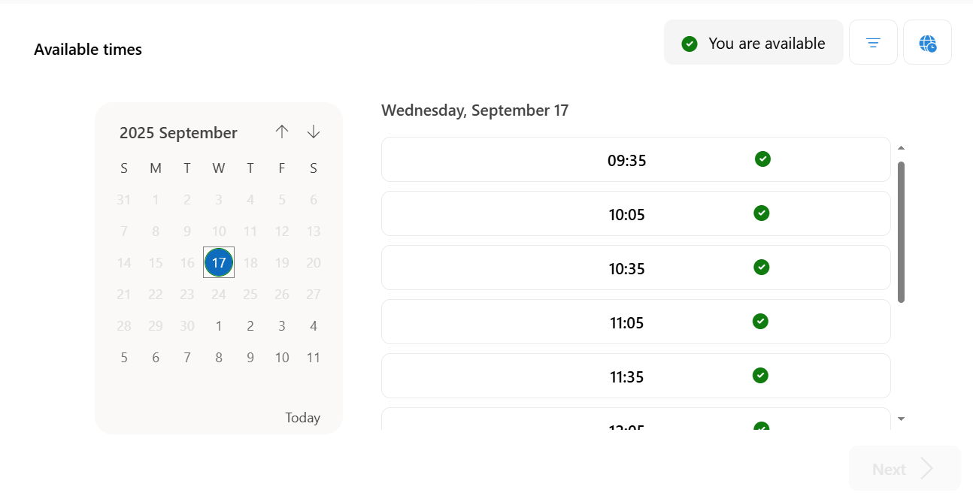

Book time with Julie McElhinney: Monday 14th Sept EY Emotional Wellbeing and Behaviour Drop-In

Book time with Julie McElhinney: Friday 25th Sept EY Emotional Wellbeing and Behaviour Drop-In

Book time with Julie McElhinney: Wednesday 7th Oct EY Emotional Wellbeing and Behaviour Drop-In

Book time with Julie McElhinney: Monday 19th Oct EY Emotional Wellbeing and Behaviour Drop-In

Book time with Julie McElhinney: Thursday 5th Nov EY Emotional Wellbeing and Behaviour Drop-In

Book time with Julie McElhinney: Wednesday 18th Nov EY Emotional Wellbeing and Behaviour Drop-In

Book time with Julie McElhinney: Tuesday 8th Dec EY Emotional Wellbeing and Behaviour Drop-In
Please complete a single service request form if you want to discuss individual children as parental consent is required. (Select EY SEND and state on the form that it’s the EY EWB drop-in session that you require).

Hertfordshire Service Request Form - Children and young people
If you are requesting general Emotional wellbeing and Behaviour advice for your cohort, then a single Service request is not required.
Any questions, please email me directly at Julie.Mcelhinney@hertfordshire.gov.uk


