Top Tips for TAs: A treasure trove of ideas for inclusive classrooms
Thursday 25th September

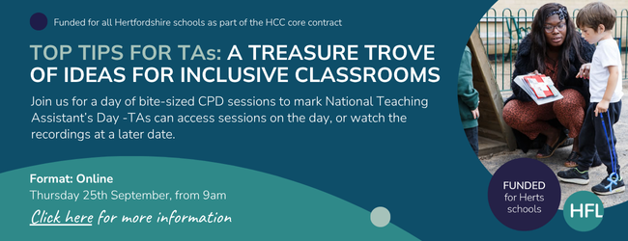
We are delighted to offer a brand-new training resource for Teaching Assistants in primary, secondary and special schools.
Sponsored by HCC, and fully funded for all Hertfordshire schools you can choose to:
- join some or all the live online sessions on Thursday 25th September 2025
- access a recording of some or all the sessions at a more convenient time.
- use the recording as part of an in-school CPD programme throughout the year.
Packed with a treasure trove of helpful ideas and resources we will share our top tips and ideas on how to make classrooms more inclusive. The practical tips align with Hertfordshire’s Ordinarily Available Provision guidance and can be implemented immediately.
Each session is just 25 minutes long, providing a perfect bite-sized tip for every Teaching Assistant.
Headteachers, SENCOs and senior leaders are invited to join us for a short introductory briefing where we will launch the new Hertfordshire TA Training Directory – a collaboration between HFL, HCC and DSPL areas.
In addition, teachers interested in finding out more about the latest research from the EEF on how to maximise the impact of TAs in an inclusive classroom can join our final session.
Please note: the live event has been planned to coincide with National Teaching Assistants’ Day which is on Friday 26th September.
Find out more about the sessions and sign up via the HFL Hub: Top Tips for TAs: A treasure trove of ideas for every inclusive classroom

