

Early Years Emotional Wellbeing and Behaviour Drop-In Sessions.

DSPL 7 & 8 – St Albans and Dacorum
Virtual DROP-IN SESSIONS for Early Years settings in SPRING Term with Julie McElhinney, an Early Years Emotional Wellbeing and Behaviour Specialist:
Book time with Julie McElhinney: Thursday 29th January 2026 EWB Drop-In
Book time with Julie McElhinney: Thursday 12th February 2026 EWB Drop-In
Book time with Julie McElhinney: Thursday 26th February 2026 EWB Drop-In
Book time with Julie McElhinney: Wednesday 11th March 2026 EWB Drop-In
If you would like advice for Emotional Wellbeing and Behaviour in the Early Years, please click on the preferred date above to book a 30-minute MS Teams time slot. Once in the booking system, please access the calendar and click on the relevant date which will then give you available time slots.
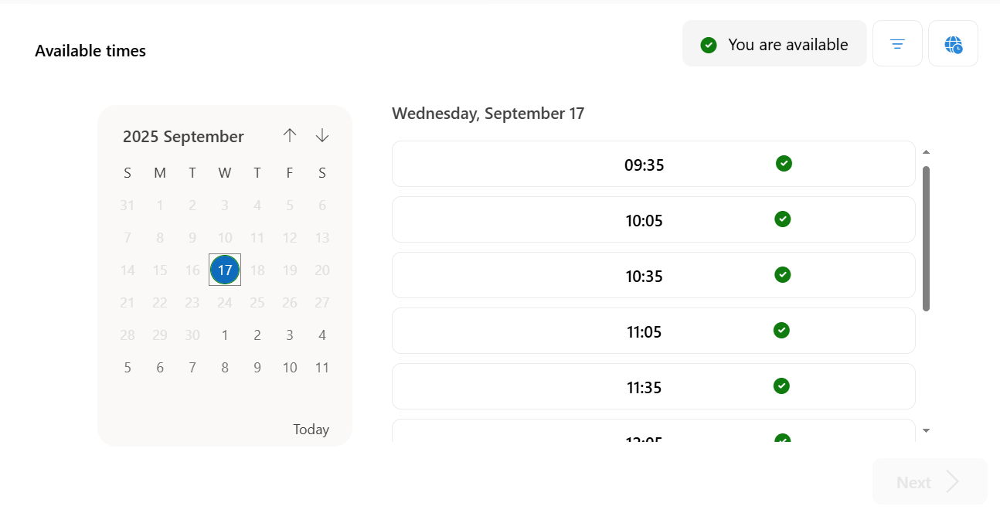
Please complete a single service request form (EY SEND and state on the form that it’s the EY EWB drop-in session that you require). Parental consent in needed to discuss individual children. Send it to STADAC.ISLTEAM@hertfordshire.gov.uk
The link for the Single Service Request Form: Hertfordshire Service Request Form - Children and young people
Any questions, please email me directly at Julie.Mcelhinney@hertfordshire.gov.uk

